For the FAS in Example 1, experimental results of the HBS algorithm under different beam widths are recorded in the following. Two instances are considered, the number of parts and the capacities of resources in each instance are
Instance 1: u₁ = u₂ = u₃ = 50, and C(m_{i}) = 3, i ∈ Z₅.
Instance 2: u₁ = u₂ = u₃ = 40, and C(m_{i}) = 4, i ∈ Z₅.
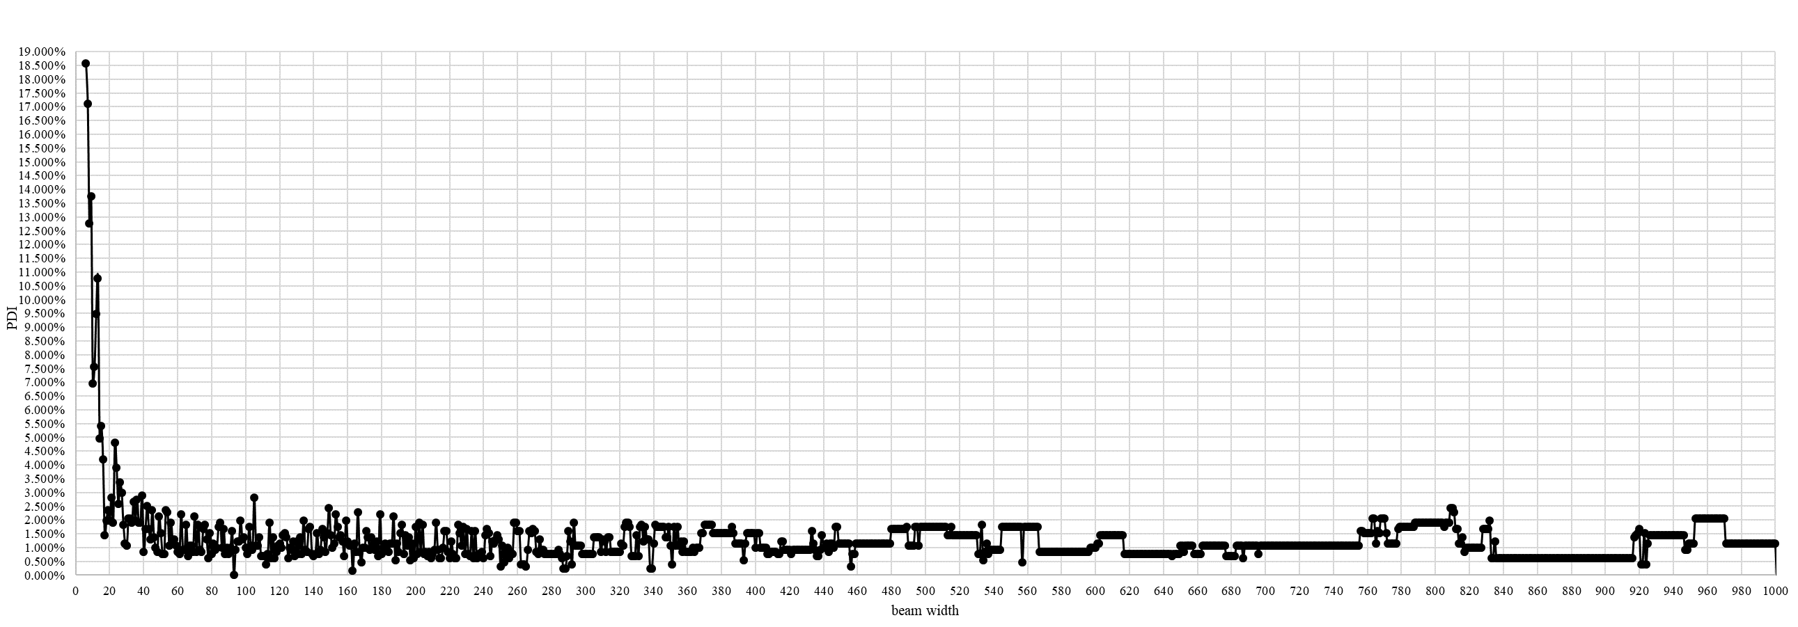
Fig. 1. PDI results of HBS algorithm under different beam widths for Instance 1.
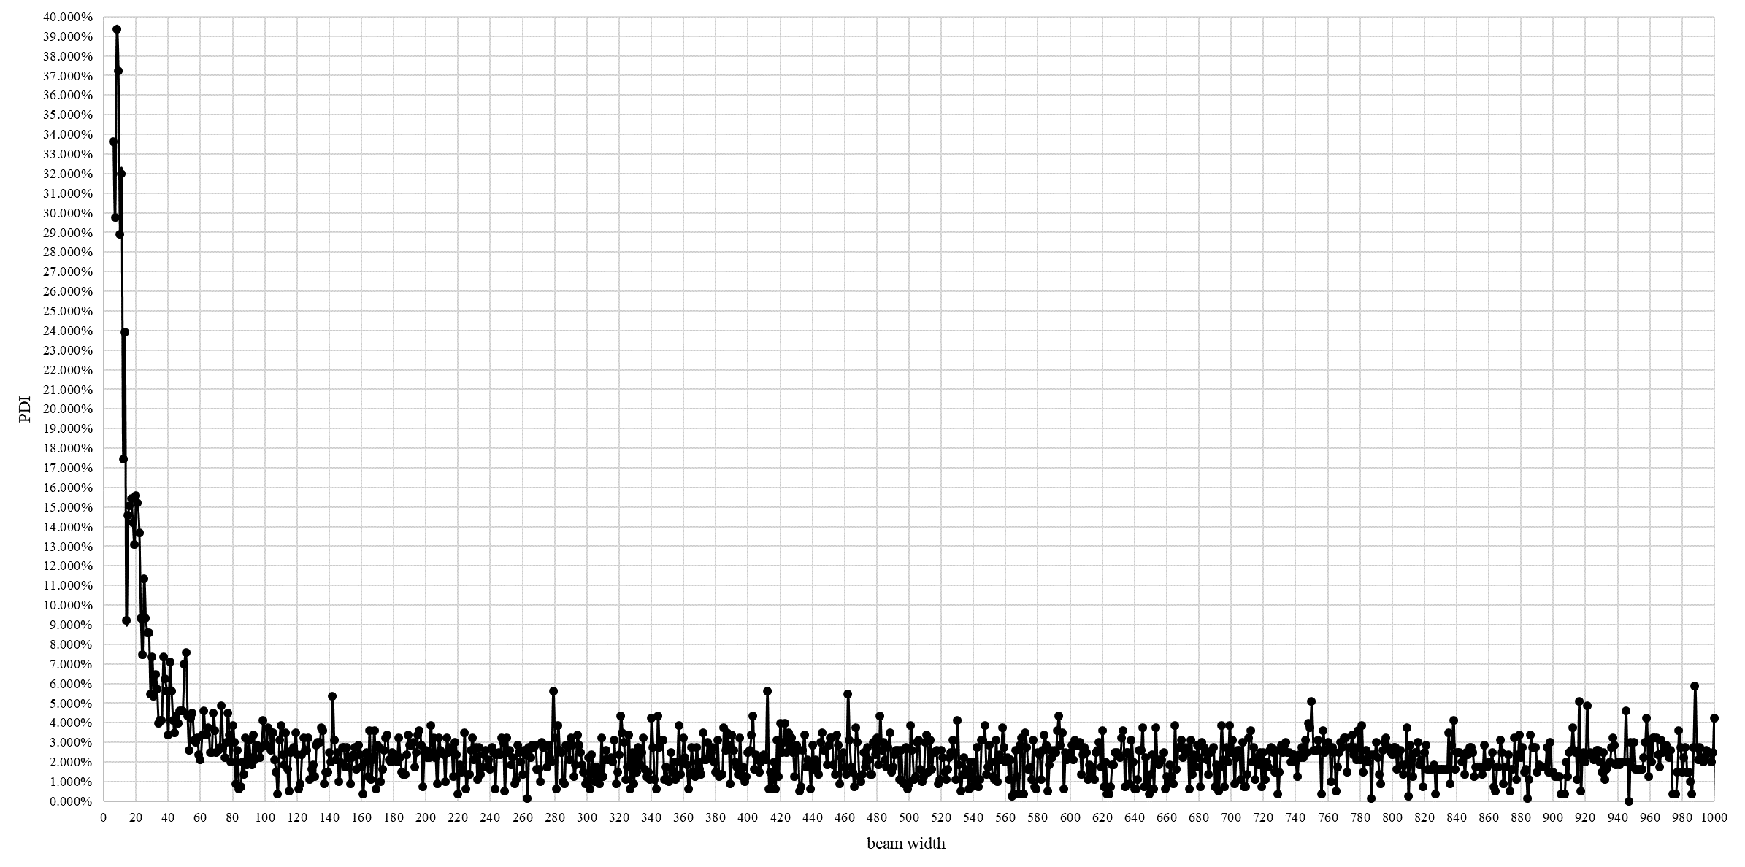
Fig. 2. PDI results of HBS algorithm under different beam widths for Instance 2.

